**DYNAMIC WEB PROGRAMMING**

**PRACTICUM 3**



**By:**

**GANNO TRIBUANA KURNIAJI**

**NIM: L200184092**

**INFORMATION TECHNOLOGY**

**FACULTY OF COMMUNICATION AND INFORMATICS**

**UNIVERSITY OF MUHAMMADIYAH SURAKARTA**

**2020**

1. **Assignment 1**

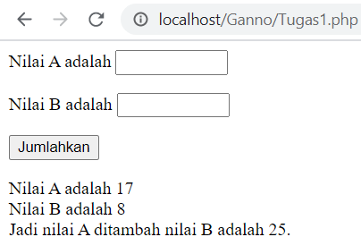

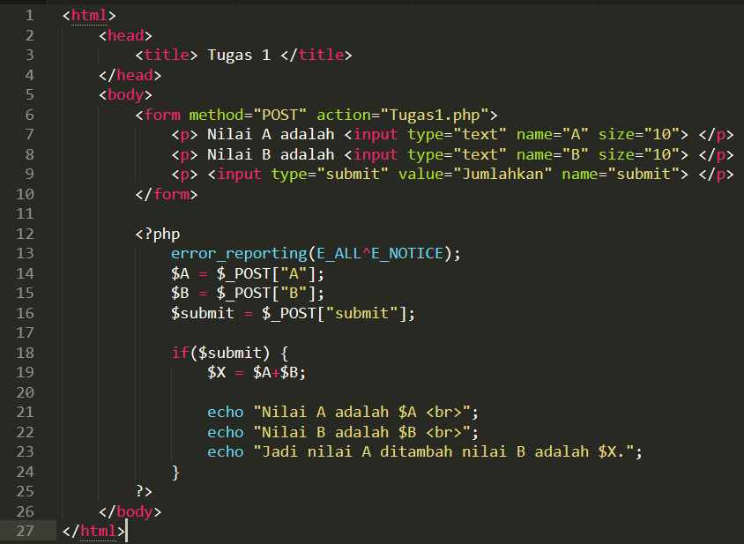

1. **Assignment 2**

